8 Port 3300-38000MHz Panel Antenna
Electrical specifications
Frequency Range (MHz) | 3300-3800
Polarization(°) | ±45
Gain(dBi) | 14
Horizontal Beam width(°) | 65
Vertical Beam width(°) | 13
Electrical Down tilt (°) | /
Electrical Down tilt Deviation(°) | /
1st Upper Side-lope Suppression(dB) | ≤-15
Front-To-Back Ratio,180°±30°(dB) | ≥25
Cross-polar Discrimination@0°(dB) | ≥16
Maximum Power per Port(W) | 100
VSWR | ≤1.5
Isolation (dB) | 26
Impedance(Ω) | 50
Lightning Protection | DC Ground

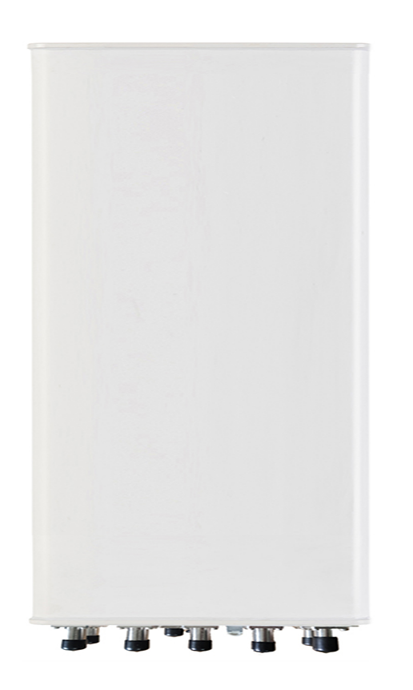

Mechanical specifications
Antenna size(mm) | 500×160×85
Packing size(mm) | 600×260×160
Antenna weight(kg) | 3
Mounting weigh(kg) | 2
Packing weigh(kg) | 6
Connector | 8*4.3-10-Female
Connector Location | Bottom
Radome Material | UPVC
Radome Color | Gray
Operating Temperature(℃) | -40～65
Operating Humidity(％) | ≤95
Wind resistance(km/h) | 210
Waterproof | IP65

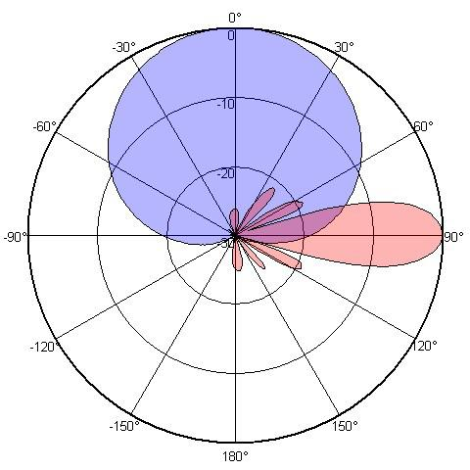

3500MHz

